A Project Documentation

On

**EVENT MANAGEMENT SYSTEM**

## Submitted By

**Pravin Tambe**

**Manisha Banerjee**

**Jyoti Ranjan Pradhan**

..

## Table of Contents

Abstract................................................................................................................................ I

List of Figures...................................................................................................................... II

List of Tables....................................................................................................................... II

1. Introduction................................................................................................................. 1
   1. Objectives................................................................................................................ 1
   2. Scope................................................................................................................. ... 1
2. System Overview…………………………….......................................................... 2

2.1 Overview……………………................................................................................... 2

2.2 Existing System……………..…………………………………………………….. 2

2.3 Proposed System…………………………………………………………………. ……. 3

**3.** Requirements for Implementation……………………………………

* 1. Use Case Diagram …........................................................................................ 5

3.2 Hardware and Software Specifications….......................................................... 7

## Abstract

Online Event Management System is an online event management system software project that serves the functionality of an event manager. The system allows only registered users to login and new users are allowed to register in the application. This is proposed to be a web application. The project provides most of the basic functionality required for an event. It allows the user to select from a list of event types eg.(Wedding party, dance show, Concerts, birthday party etc). the system then allows the users to select the date and time of the event. Users data will be handled by admin part and admin has the right to make further changes as per the requirements.

I

## List of Figures

Fig 2.3.1 Proposed System………………………………………………………………. 3

Fig 3.1.1 Use case diagram(User)……………………………………………………….. 5

Fig 3.1.2 Use case diagram(Admin)………………………………………………………. 6

## List of Tables

Table 3.1.1 Hardware Details……………………………………………………………… 7

Table 3.1.2 Software Details……………………………………………………………… 7

II

**Chapter 1**

## Introduction

### **Introduction**

When organizing an event, we have to go to the particular office and enquire about the event details and have to pay the required amount, based on what event we have opted.

If we are doing it manually it becomes a tedious process as more manpower is required to handle the processes. But there are some drawbacks for this existing system such as there is no security of data and data can be misplaced.

The ‘Event management system’ has been developed to override the problems prevailing in the practicing manual system. This software is supported to eliminate and, in some cases reduce the hardships faced by this existing system. Moreover, this system is designed to carry out operation in a smooth and effective manner.

**1.2**​ **Objectives**

The main objective of the Event management system is to build an application program to reduce the manual work for managing the event, enquiring, booking, it tracks all the details about the booking, package. As this project contains administrative module wherein admin will validate the users for security purposes.

#### 1.3 Scope

The scope of event management system provides a wide variety of career that could be anything from concerts, conferences, wedding party, birthday party, etc.

The objective of this application is to develop a system that effectively manages all the data related to the various events. The purpose is to maintain a centralized database of all event related information. The goal is to support various functions and processes necessary to manage the data efficiently.

1

**Chapter 2**

## Proposed System

### **2.1 Overview**

The following reasons related to existing system can be considered which affects the efficient management of an event.

* The existing system is more time consuming and requires more man power.
* There is no security of data.
* There is no data maintenance.
* Information can be misplaced.

#### 2.2 Existing System

The existing system is not providing secure registration and profile management of all the users properly. The system is not providing online help. It does not provide tracking of user’s activities and their progress. This manual system gives us very less security for saving data and some data may be lost due to mismanagement. This system is not providing event management through internet. It does not provide proper events information. This system is giving manual information through the event management executer.

2

#### 2.3 Proposed System

The proposed system is a web application that overcomes the drawbacks of the existing system. The general block diagram of the Proposed system is shown in the fig 2.3.1

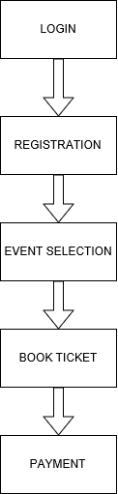

Fig 2.3.1 Block diagram of proposed system

3

Listed below are the modules in the Proposed system:

#### 1 Login:​

Valid Username and password must be provided in order to further Log in.

1. **User Registration:**

Registration depends on certain criteria which includes minimum age, languages known etc

1. **Event Selection:**

It includes selection of Events(Wedding party, Birthday Party, Concerts, etc.).

#### 4 Book Tickets

Respective event tickets will be provided along with the payment module.

4

##### 3. Implementation Details

The use case diagram explains the interaction of user with the system.

###### 3.1 Use Case Diagram

**1)USER**

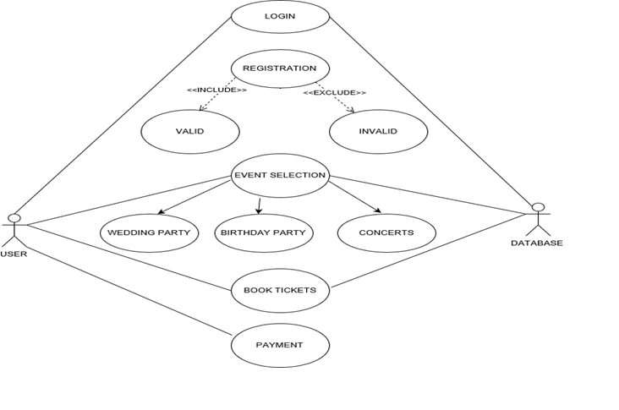

Fig. 3.1.1 Use Case Diagram for the proposed system

5

**2)ADMIN:**

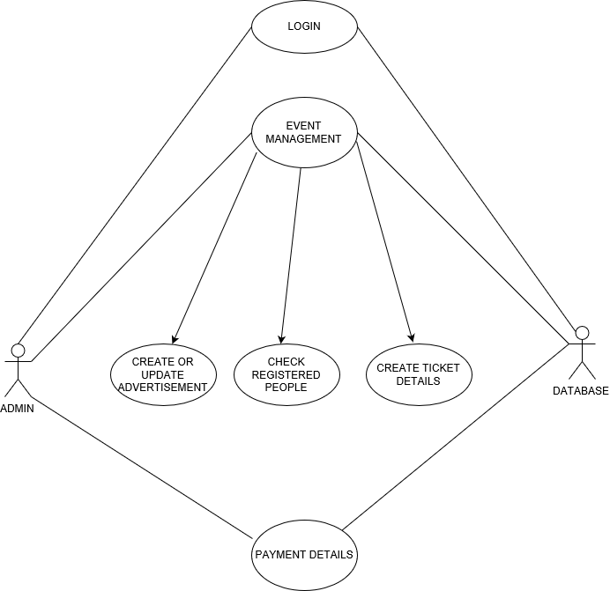

Fig. 3.1.2 Use Case Diagram for the proposed system

6

#### 3.2 Hardware and Software Specifications

The experiment setup is carried out on a computer system which has the different hardware and

software specifications as given in Table 3.2.1 and Table 3.2.2 respectively.

### Table 3.2.1 Hardware details

|  |  |
| --- | --- |
| Processor | 3.2 GHz Processor or above |
| HDD | Greater or equal to 40 GB |
| RAM | 8 GB |

### Table 3.2.3 Software details

|  |  |
| --- | --- |
| Operating System | Windows-10 |
| Programming Language | Java |
| Database | MySQL/Oracle |
| Framework | Angular |

7